**Name: VISHNU SADASIVAN**

**Roll No: 52**

**Batch:MCA-B**

**Date: 08-03-2022**

**ADVANCED DBMS LAB**

**EXPERIMENT NO.: 3**

**Aim**

To familiarize DDL Commands- ALTER,DROP,TRUNCATE,RENAME

**QUESTION**

1.Create a table emp with attributes empno number(4)as primary key, ename char(10),hiredate,  salary, commission

insert 5 rows of data

|  |  |  |  |  |
| --- | --- | --- | --- | --- |
| 101 | Ramesh | 17-Jan  1980 | 5000 |  |
| 102 | Ajay | 05-Jul  1985 | 5000 | 500 |
| 103 | Ravi | 12-Aug  1981 | 1500 |  |
| 104 | Nikesh | 03-Mar  1983 | 3000 | 700 |
| 105 | Ravi | 05-jul  1985 | 3000 |  |

2.Modifying the structure of tables

a.Add new columns: sal number(7,2)

b.Dropping a column from a table: sal

c.Modifying existing column :ename varchar2(15)

d.Renaming the tables: emp to emp1

e.truncating the tables:emp1

f.Destroying tables:emp

3.Create a table stud with sname varchar2(20) primary key , rollno number(10) not null,dob  date not null

4.Create a table student as regno number (6), mark number (3) check constraint (mark >=0 and  mark  <=100));

In table student add check constraint(length(regno<=4))

5.Create a table cust with(custid number(6) constraint unique, name char(10) 6. Refer the table “stud” in table “ student”

**PROCEDURE AND OUTPUT SCREENSHOT**

1. **EMP TABLE (CREATE AND INSERT)**

CREATE TABLE EMP(EMPNO INT(4) PRIMARY KEY , ENAME CHAR(10),HIREDATE DATE,SALARY INT(5));

INSERT INTO EMP(EMPNO,ENAME,SALARY,COMMISION)VALUES(‘101’,’RAMESH’,’1980-01-17’,5000,500),(‘102’,’AJAY’,’1985-07-05’,5000,500),(‘103’,’RAVI’,’1981-08-12’,1500,150));

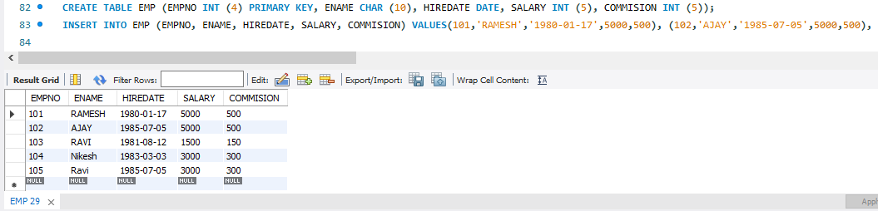

**2.MODIFYING THE STRUCTURE OF TABLES**

**a.ADD NEW COLUMNS: SAL NUMBER(7,2)**

ALTER TABLE EMP ADD SAL INT;

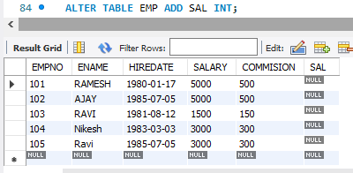

**b.DROPPING A COLUMN FROM A TABLE: SAL**

ALTER TABLE EMP DROP COLUMN SAL;

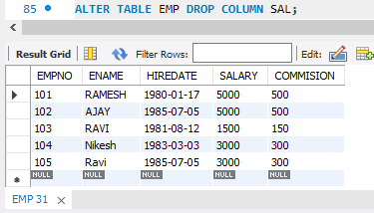

**c.MODIFYING EXISTING COLUMN :ENAME VARCHAR2(15)**

ALTER TABLE EMP MODIFY ENAME VARCHAR(15);

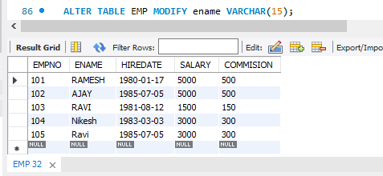

**d.RENAMING THE TABLES: EMP TO EMP1**

RENAME TABLE EMP TO EMP1

SELECT * FROM EMP1;

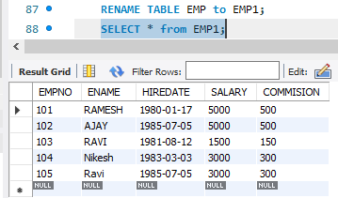

**e.TRUNCATING THE TABLES:EMP1**

SELECT * FROM EMP1;

TRUNCATE TABLE EMP1;

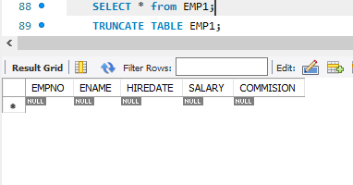

**f.DESTROYING TABLES:EMP**

DROP TABLE EMP1;

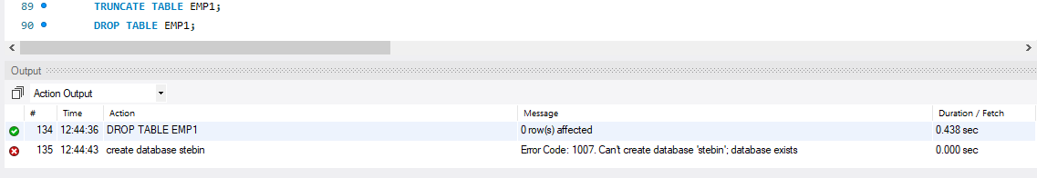

**3 .STUD TABLE**

CREATE TABLE STUD(SNAME VARCHAR(20) PRIMARY KEY,ROLL NO INT NOT NULL,DOB DATE NOTE NULL);

SELECT * FROM STUD;

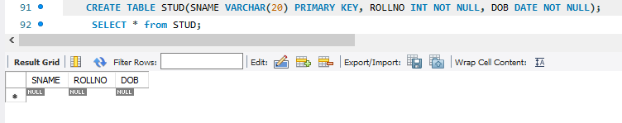

**4.STUDENT TABLE**

CREATE TABLE STUDENT(REGNO INT,MARK INT(3) CONSTRAINTS B CHECK (MARK >=0 AND MARK <=100));

SELECT *FROM STUDENT;

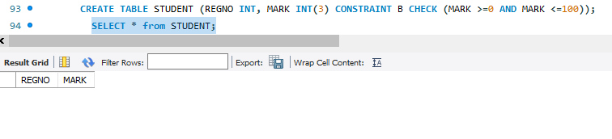

**5. CUST TABLE**

CREATE TABLE CUST(CUSTID INT(6) NOT NULL UNIQUE,NAME CHAR(10));

SELECT * FROM CUST**;**

